Simulating SDI trajectories from R
From a mathematical perspective, the way “10” pattern trajectories are simulated is the following:
- The parametrization is the true value of breakpoints coordinates at population level
- From this, breaks are simulated at the individual level, (x,y)-coordinates being independently generated.
  - On the x-axis (time), the distance between breaks is simulated with a log normal distribution based on the parameters given by the user.
  - On the y-axis (SDI), the height is simulated with a normal law truncated between 0-10, which are the boundaries of SDI scale.
- After computing individuals’ breakpoints, when can derive the true individual trajectories (on a continuous 0-10 scale), from which we add (gaussian white) noise to derive the noised individual trajectories.
- Finally, the score is computed by rounding the noised trajectories to the closest integer in the range of the scale.
- One optional last step consists of adding:
  - Outliers, at most one per patients, and simulated by a drop is measured score by 1-3 points with higher probability on higher drops
  - Missing values (completely at random)
From a coding perspective, a way to simulate SDI trajectories from known breakpoints (with log-normal distance between them) is described in the following 2-step process:
- trueTraj: Specify the population-level average of breakpoints parameter.
Population-level specification includes “10”-pattern of the trajectory, breakpoints average coordinates, and times of measurement during the experiment (i.e. on average, when are the patient solicited for SDI).
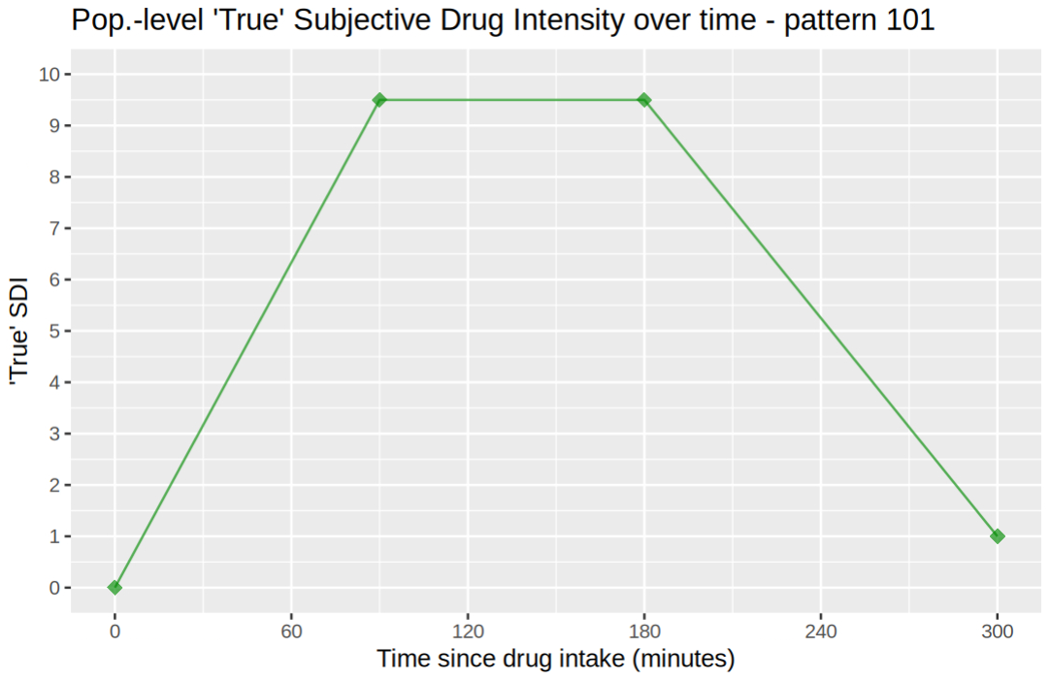
Figure 1 - Default plotting method for object of class `trajTruth`

- noiseTraj: Simulate individuals by specifying the level of noise on each parameter.
The noise level for the parameters is considered as the standard deviation for the (log-) normally distributed parameters listed below:
- times: sd on the times of measurements during the simulated experiment
- score: noise added on top of the true theoretical individual trajectory (final score variable is rounded to closest integer)
- breakpoints.sd: sd of log-normal distribution of distance between breakpoints for x axis, and normally distributed for y axis. Needs to be specified for both x and y coordinates, which are simulated independently.
Other parameters include:
- n.obs: number of individuals to simulate in the dataset.
- break.x.dist: minimum between-breakpoints distance on the time axis.
- outlier.prob: individual probability of having exactly one outlier observation. Outliers are simulated as a drop of 1-3 points in score, to mimic the impact of going to the bathroom during the experiment.
- na.prob: observation probability of being a missing value
- n.trail: number of trailing observations at the end of the trajectory. Ignored if simulated pattern already ends with a plateau. Exact number may vary individually due to noise on the time of measurement. Default is -1, meaning we don’t wait until return to true normal level of SDI to finish the experiment.
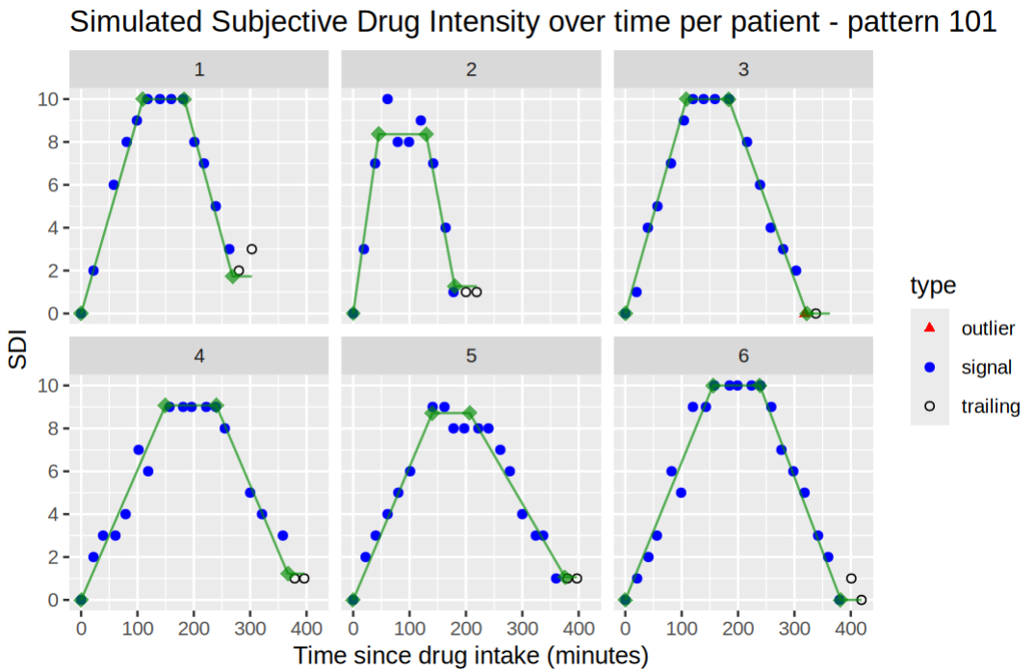
Figure 2 - Default plotting method for object of class `trajData`
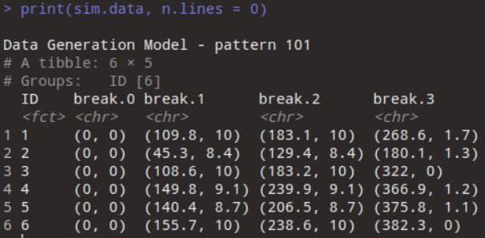
Figure 3 - 'print' method for objects of class 'trajData'
Default ‘plot’ represents the measurement with type (signal, outlier, trailing) along with true individual trajectories. It can be restricted on certain patients with cluster argument. ‘print’ gives the individual true breakpoints values and can also display simulated data.
In this example we used the pattern “101” to illustrate, but the function works for every “10”-alike pattern. Pattern of interest to us are 11, 101, 111, 1010 and 1011. The way to change the simulated pattern essentially resides in the design of breakpoints dataframe.
See full R script on next page or W:\noahdegoulange\github\mixedBreak\test\noiseTraj-Ex.R
source("R/trueTraj.R")
source("R/noiseTraj.R")
source("R/plot.R")
source("R/print.R")

## Specifiying parameters and noise level
times <- list("value" = 20, "sd" = 2)
break.3 <- data.frame(
pattern = c(1, 1, NA),
bp.x = c(0, 180, 300), # psi, time coordinate of breakpoints
bp.y = c(0, 9.5, 1), # height of breakpoints
bp.x.sd = c(0, 50, 50), # noise levels
bp.y.sd = c(0, 1, 1)
)

outlier.prob <- 1 / 2 # individual probability of having exactly one outlier observation
na.prob <- 1 / 10 # measurement probability to be missing
n.trail <- 2L # nb of trailing observations (default is -1)
break.min.dist <- list(x = 45, y = 0) # min between-breakpoints distance

n.obs <- 6L # nb of patients
score.sd <- .5

true.traj <- trueTraj(times[["value"]], break.3[1:3])
plot(true.traj)

sim.data <- noiseTraj(true.traj, n.obs, score.sd, times.sd = times[["sd"]],
breakpoints.sd = break.3[4:5], break.x.dist = 20,
outlier.prob = outlier.prob, na.prob = na.prob, n.trail = n.trail)
plot(sim.data)

